 **Screening and Patient Management Algorithm**

**for** **Ebola Virus Disease (EVD)**

**Notes:**

1. Typical symptoms: fever, headache, joint/muscle aches, weakness, diarrhea, vomiting, abd pain, lack of appetite. Some patients may report additional symptoms.
2. Western Africa = Guinea, Sierra Leone, Nigeria, Liberia. Note: Other African countries have had Ebola historically, but Western Africa is the location of the most recent outbreak.
3. Close contact = any person who provided care for the patient or had similarly close physical contact; or stayed at the same place as the patient while the patient was ill.

**Precautions:**

* Respiratory etiquette for all patients including mask.
* Remove patient from waiting area
* Droplet & Contact Precautions. This includes mask, face/eye protection, gown, & gloves.

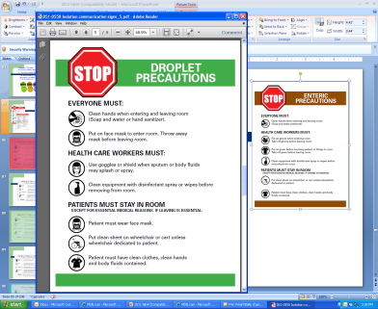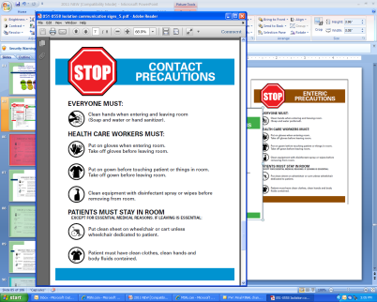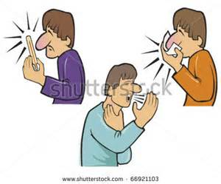[](http://www.bing.com/images/search?q=check+mark&qs=n&form=QBIR&pq=check+mark&sc=8-6&sp=-1&sk=#view=detail&id=FE23A8F077B37E7AB61DDDDE8EA4094450D1D400&selectedIndex=28)

Follow routine practices; Standard Precautions

YES

NO

NO

NO

NO

YES

YES

YES

* Place mask on patients.
* Initiate Droplet and Contact Precautions. This includes mask, face/eye protection, gown, & gloves.
* Communicate necessary precautions prior to hospital admission.
* **Notify Infection Prevention & Control for Coordination**.
* Contact Department of Health 24/7 (Tel #).
* Notify lab before ordering tests or sending any specimen.
* Submit specimens for testing per public health instruction.
* Initiate Infectious Disease consult if not already done.

Consult with Infection Prevention before discontinuing Precautions.

* Continue Droplet and Contact Precautions.
* Initiate investigation for any exposure.
* Reinforce necessary precautions/protection.
* Collaborate with public health.
* Collaborate with Infection Prevention and Control.

Follow routine practices; Standard Precautions

Is testing for EVD Positive?

Patient presents to the clinic or ED

Is the patient a close contact3 of someone with these symptoms within the prior 21 days?

Does patient have sudden onset of fever, malaise, myalgia, headache, vomiting, diarrhea, or other non-specific signs1?

This tool, the screening criteria and recommended precautions are subject to change based on new information from the WHO, CDC and/or Department of Health.

Has patient traveled to or resided in Western Africa2 in the 21 days prior to onset of illness?